**Assignment – 1**

**Python Programming**

|  |  |
| --- | --- |
| Assignment Date | 08 September 2022 |
| Student Name | Mr. T. Logavarthan |
| Student Roll Number | 142219106048 |
| Maximum Marks | 2 Marks |

**TASKS:**

# 1. Split the String

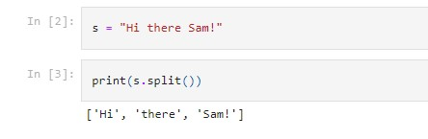

2. Use .format() to print the following string.

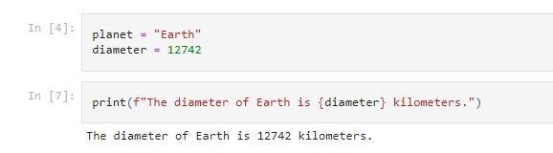

# 3. In this nest dictionary grab the word "hello"

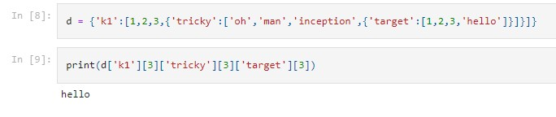

# 4. Numpy Import numpy library



4.1 Create an array of 10 Zeros.



4.2 Create an array of 10 fives.

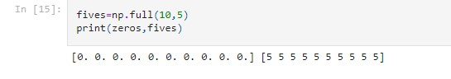

# 5. Create an array of all the even integers from 20 to 35

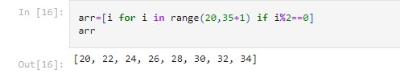

# 6. Create a 3x3 matrix with values ranging from 0 to 8

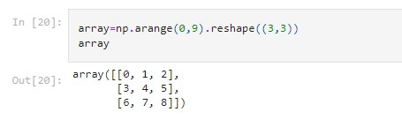

# 7. Concatenate A and B

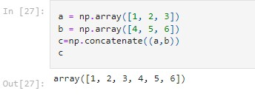

# 8. Create a data frame with 3 rows and 2 Columns

**Import PANDAS**



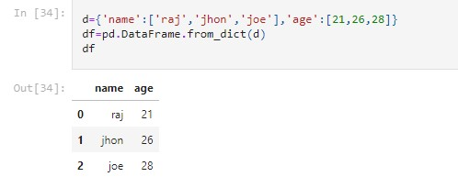

# 9. Generate the series of dates from 1st Jan, 2023 to 10th Feb, 2023



DatetimeIndex(['2023-01-01', '2023-01-02', '2023-01-03', '2023-01-04',

'2023-01-05', '2023-01-06', '2023-01-07', '2023-01-08', '2023-01-09', '2023-01-10',

...

'2023-09-23', '2023-09-24', '2023-09-25', '2023-09-26',

'2023-09-27', '2023-09-28', '2023-09-29', '2023-09-30',

'2023-10-01', '2023-10-02'],

dtype='datetime64[ns]', length=275, freq='D')

# 10. Create a 2D List to DataFrame

